Dear Parents, Carers, Friends and Colleagues,
Today is the last day of school for a week as next week is half term. We shall return as normal on Monday 2nd November at your child’s usual start time:
 | Winter gate | Pedestrian gate
8:30 to 15:15 | Nursery and Reception | Resource Base
8:35 to 15:20 | Y2 | Y1
8:40 to 15:25 | Y4 | Y3
8:45 to 15:30 | Y6 | Y5

All the staff appreciate your patience and your cooperation at the beginning and the end of the day to make sure that everyone is safe.
It is important that you bring your child to school at the time given for their class, otherwise we may have to ask you to wait to make sure that all the classes are kept safe and socially distanced from each other.
Homework and holiday work
Today we will give out homework and holiday work in paper form. It is also available online via your child’s SeeSaw or Google Classroom account, which you have been sent the passwords for. After half term we are looking to move homework to being online. If this is difficult for your child to access, please call the school and let us know why this is, we may be able to help.

Half term holiday
If you are planning to go away during this half term, please make sure that you follow the Government guidance about the travel restictions that are in place. You may be able to travel to countries that require you to self-isolate on your return. This would result in your child not being able to return to school on 2nd November. Please check the guidance, which was updated yesterday www.gov.uk/guidance/coronavirus-covid-19-travel-corridors
It is very important that you follow the government advice to ensure that you, your family and everyone at school is kept safe and free from any risk of infection.
If you are going on holiday, please call Mrs. Gibbs and let her know so we can help to support your safety.
Creative Wandsworth Arts
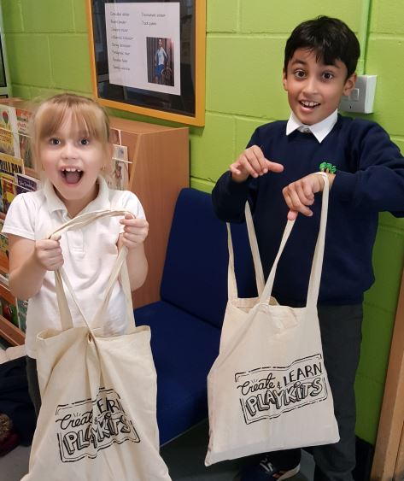
We are very grateful that Battersea Arts Centre have delivered enough Create and Learn Playkits for all the children in Y1, Y2, Y3, Y4 & RB to take one home to keep and use during the half term holiday. These playkits have been put together by a group of organisations from Wandsworth. What a wonderful gift! Please send us photos of anything you make. #createandlearnplaykits
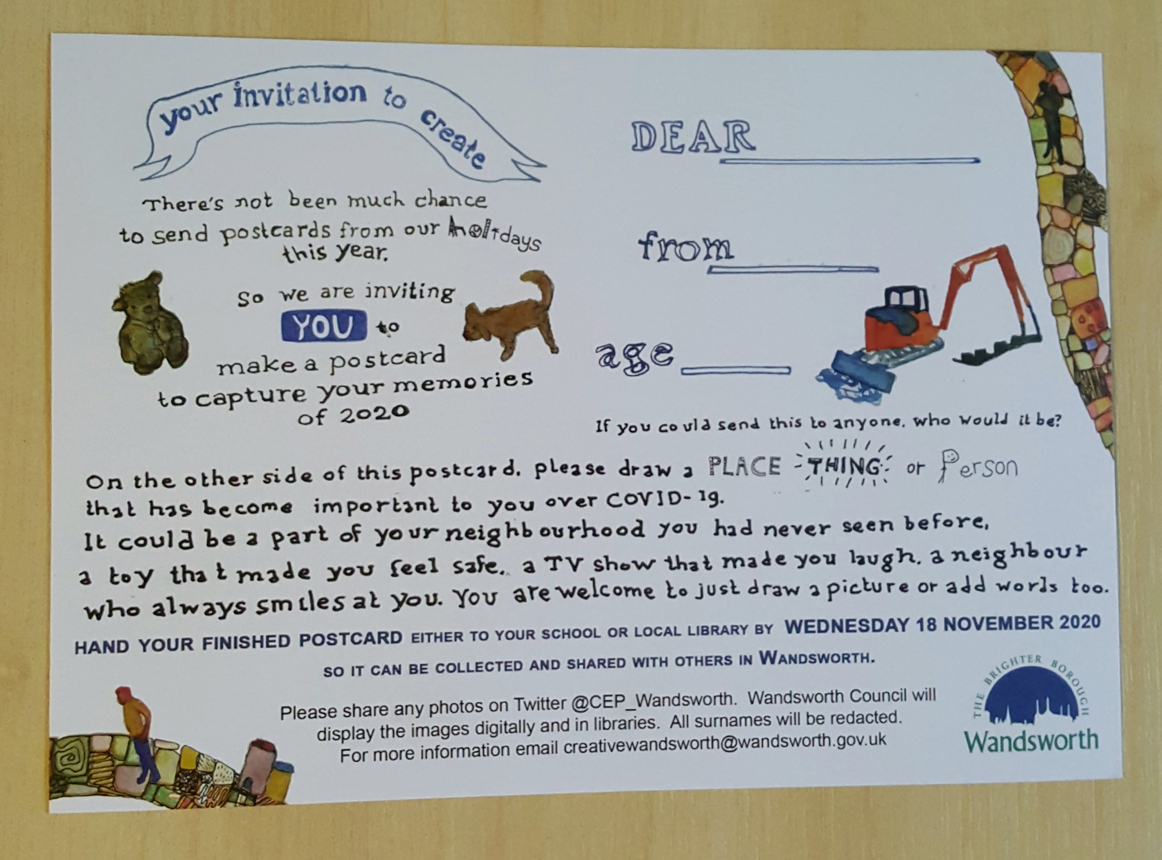
We also sent home some postcards yesterday for your children to complete with images of a place, thing or person that has become important to them over Covid-19. Once completed, they will be shared on twitter @CEP_Wandsworth and within the local community. Please bring you completed postcards to the library or school after the holidays
Reading Books
Please remember to return your child’s reading books on Fridays only, we will not be accepting them on other days after half term. This is because we need to ‘quarantine’ the books before they can be used again and the time we use for this is crucial.
Parents’ Meetings
Thank you to all of you who gave your time to meet your child’s teacher during our Parents’ Meetings. The teachers really enjoyed talking to you about your child and I enjoyed seeing many of you too. If you have not yet had your meeting, you can call the school or leave your child’s teacher a message on SeeSaw or Google Classroom and they will get back to you.
We have new videos from your child’s teacher on our website.
They are sharing the work that your children are doing, so please take a look before your appointment:
https://www.altonschool.org.uk/our-learning/curriculum-autumn-one
Excellent Learners
This week our achievement certificates went to:
Excellent Learners: Ali(YN); Ayesha(YR); Muneefa(Y1); Yahia(Y2); Maida(Y3); Hayley(Y4); Archie(RB); Danish(Y5) & Mohamad(Y6).
Writers of the week: Gabriel(YN); Akram(YR); Aden(Y1); Sumaiya(Y2); Barriah(Y3); Angelina(Y4); Jamie-Leigh(RB); Maryam(Y5) & Hamza(Y6).
Mathematician of the week: Awab(YN); Lailah(YR); Alissa(Y1); Kazeem(Y2); Samira(Y3); Khalifah(Y4); Amr(RB); Hebron(Y5) & Charlie(Y6).
Reader of the week: Natalia(YR); Anes(Y1); Hamza(Y2); Omar(Y3); Imran(Y4); Nikolay(Y5) & Aryan(Y6).
Staff Needed
We are currently looking for two part-time Learning Support Assistants to support children’s learning in the classroom. If you are interested in applying for this post, you will find the application form on our website. If you would like to discuss this with someone, please call the school and speak to Mrs. Matthews.
Harvest
We were overwhelmed by your generousity for our collection for the Wandsworth Food Bank. Thank you so much! Because London went into Tier Two Covid restrictions, the School Councillors could not take the food to the food bank, so staff took it instead. It was very gratefully received. We delivered more than 12 boxes of food.
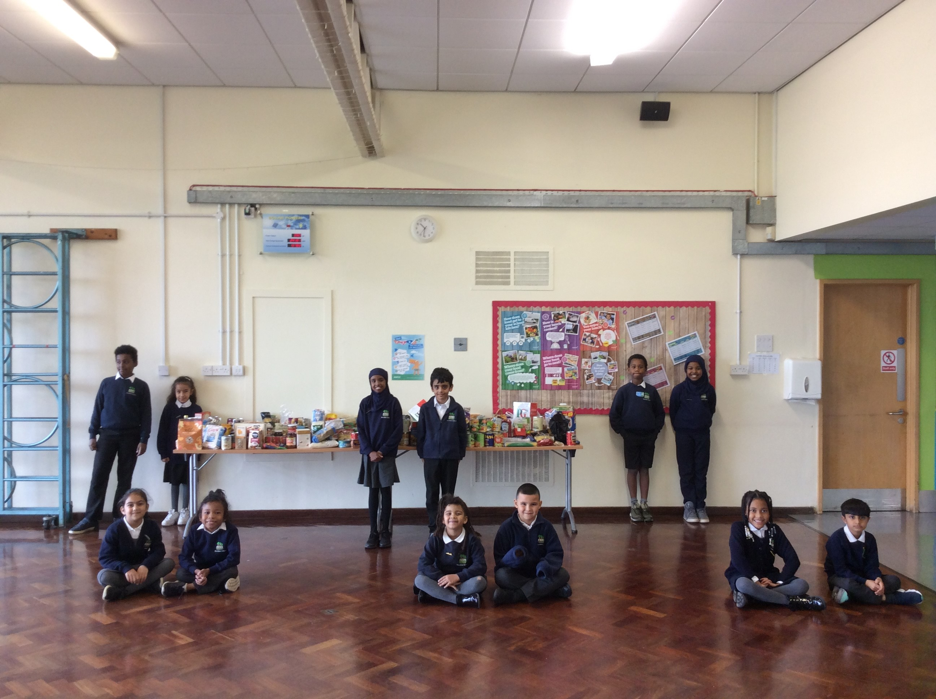
Social Media
The children have already produced some fantastic work this year. Keep following our social media so that you can see all the new pictures and activities the children are doing as they are published.
Instagram: The_alton_primary_school Twitter: @thealton
Reporting Absence
Please report any sickness in the normal way for your children, by calling the school between 8am and 8.15am to let Mrs Gibbs know. Please remember that if you are reporting that your child has a temperature or a cough, we will ask you to call 119 to get advice on whether you should book a test to check if your child has coronavirus. Your whole family will need to self-isolate until you know the result of the test. We will also expect you to inform us of the result of the test.
Suggestions and questions
Parents make many helpful suggestions and ask very good questions so I would like to use the newsletter to take one of these and answer it each week. A parent wrote:
“I don’t understand why the children cannot line up outside of the school in their classes and then be called in by the teachers. I am often in a hurry and do not have time to wait with my child. Could this happen?”
Thank you for your question. The latest time that children currently come into school is the same time that it was last year, before Covid 19 and all the new rules that we ask you to follow to keep everyone safe. If you need to leave before 8:45, we do have Breakfast Club available from 7:45 every day. This must be booked and paid for in advance. The cost is £2.50.
We do not have enough staff available to supervise the children if they were to be left outside the school without you looking after them. Until the school day starts, your child remains your responsibility and always has been.
It is really important that you keep your child with you at all times until a member of staff calls your child in.
Yesterday and today, a number of children lined up along the fence by the pedestrian gate without their parents, which is not safe for the children themselves or for other members of our school community. Please make sure that this does not happen again.
I hope we can all work together to make sure that everyone is kept safe and feels safe.
If you have a question or suggestion please email:
admin@thealton.wandsworth.sch.uk
Or you could write to me. I am sure your suggestions and questions will be useful to other parents as well.
With best wishes,
Ruth Hudson
Headteacher

Dates for your diary
26th to 30th October school is closed to pupils – half term holiday
2nd Nov 7.45am Breakfast club. 8.30am classes start.
5th Nov Flu immunisations
17th Nov Individual School Photographs
18th Dec Last day - School closes for Christmas
21st December 2020 to 7th January 2021School is closed to pupils
4th Jan School closed to pupils but open for staff training
5th Jan 7.45am Breakfast club. 8.30am classes start.
12th Feb School closes for half term
15th to 19th February School closed to pupils – half term holiday
22nd Feb 7.45am Breakfast club. 8.30am classes start.
31st Mar School closes for Easter
1st April to 16th April School is closed to pupils – Easter Holidays
19th Apr School closed to pupils but open for staff training
20th Apr 7.45am Breakfast club. 8.30am classes open.
3rd May School closed for Bank Holiday
28th May School closes for half term
31st May to 4th June School is closed to pupils – half term holiday

7th June 7.45am Breakfast club. 8.30am classes start.

23rd July 2021 Last day of school before school closes for the summer

