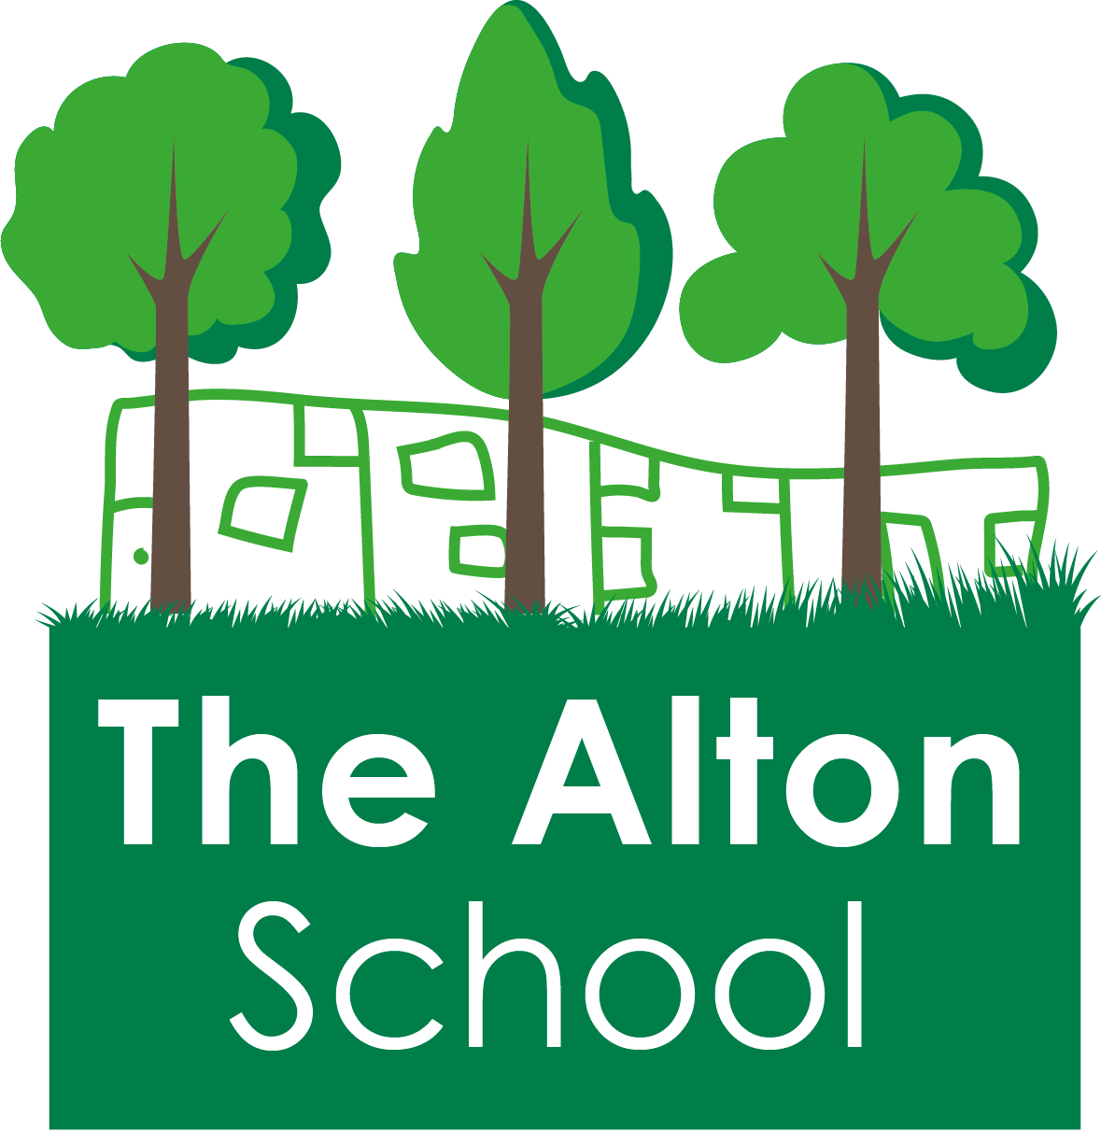
The Alton School Newsletter

Dear Parents, Carers, Friends and Colleagues,
Half term
Next week is half term. I hope that you all have a happy and peaceful week. Please encourage your children to complete their half term homework to help with their learning.
When your children return to school on Monday 29th October 2018 at 7.45am for Breakfast Club or 8.30am for school, please make sure they wear a coat to school. Hoodies are not part of our uniform and should not be worn to school. The weather is no longer warm and the pupils need coats at play and lunch time to keep warm.
Rights Respecting School
After half term we will be focusing on Article 13: You have the right to find out things and share what you think unless it harms or offends others. The students will learn that with this right comes the responsibility to make sensible choices to keep themselves and others safe.
Our Excellent Learner quality will be: Ask questions.
Please support us by using the language of Excellent Learners as well as rights and responsibilities with your children, asking them what they have been learning about.
Volunteer Readers
Do you have some time that you could spend with us to volunteer to hear children read? Are

19th October 2018

you a passionate reader who would love to share your love of stories? If you don’t have time, do you know someone who does? We would love to have some parents or carers or community members work in our school, reading with our wonderful pupils. If you could help, please see Mrs. Harwood or Mrs. Gibbs to find out more.
School uniform
Thank you to all of you who have ensured that your children come to school in full uniform. We always do our best to liaise with suppliers to keep school uniform costs as low as possible, and to provide high quality clothing. Due to increased supplier costs we have had had to slightly increase the cost of our school uniform. The cost of school uniform is now:-
Sweatshirt - £10
Cardigan - £14
Polo shirt - £7
Fleece - £13
PE T-shirt £3
Book Bag - £5
Rucksack - £10
Beanie Hat - £5
School Pick Ups
Please can you make sure that your school pick up lists are always kept up to date, by coming into the office at the beginning or the end of the day and speaking to Mrs. Gibbs whenever there are changes. Or you can email admin@thealton.wandsworth.sch.uk.
We are receiving last minute telephone calls to change the collection arrangements for your children on the same day. We understand that emergencies can sometimes happen, however these calls are becoming very frequent. This is a busy time of the school day and such calls can lead to unnecessary phone calls to parents and to delay. Please help us by letting us know of any changes in the morning when you drop your child off.
In order to keep your child safe, we are unable to let your child go home with someone who is not on the list.
Flu Immunisations
Flu immunisations are available for all pupils from Reception to Year 5. Please make sure that you return your consent form to the office as soon as possible.
Medical Appointments
Although we understand that medical appointments in school time are sometimes unavoidable, we do ask that you keep these appointments to a minimum and try to organise them out of school time as much as possible. Each time your child leaves or enters a class during a lesson, in addition to your child’s own loss of learning, the whole class is disrupted and the teacher must spend additional time away from the whole class explaining to your child the parts of the lesson that have been missed.
From Monday 29th October we will be changing the way that we record medical appointments on the register so if your child has a medical appointment during school time it will be marked in the register so that all absences are recorded and this will show on your child’s official record of attendance. This may effect whether your child has 100% attendance in the future.
Please make sure that you continue to bring proof of all unavoidable medical appointments during school time to the office.
Staff changes
Ms. Eleni is leaving at half term to begin a new career working with pupils in a post-16 college. We all wish her good luck!
Mr. Sarker has decided to resign his post and I am happy to tell you that Ms. Bashir is joining us for the day on Friday 19th October, and then as the Y6 Class Teacher after half term. I know you will all welcome her to our school.
This week at The Alton
On Monday, we held our Achievement Assembly and the following students were awarded their certificates:
Writers of the Week: Musab(YN); Tamseela(YR); Abduraham(Y1); Cameron(Y2); Danish(Y3); Safa(Y4); Jaden(Y5) & Shawar(Y6).
Mathematician of the Week: Jeremiah(YR); Barriah(Y1); Marwa(Y2); Zaihab(Y3); Aaliyah(Y4); Nastaran(Y5); Aleem(Y6) & Ben(RB);
Excellent Learners: Nadira(YR); Hamza(Y1); Jazib(Y2); Maryam(Y3); Charlie(Y4); Ayman(Y5); Freddie(Y6) & Cole(RB).
Reader of the Week: Saim (Y1)
Best Class Attendance: Year 3 100%
Top Table: Cody Y3
Best Class in Assembly: YR
P2B Kindness Cup: YR

Also on Monday, John Grove, the Executive Headteacher of our Q1e Trust, visited and spent time with the pupils and staff. As usual, he was very impressed with The Alton School!
On Wednesday, Year 3 had such good attendance that they had a non-uniform day.
Also on Wednesday, we held our Pupil Progress meeting to assess the progress that your children have made this half term. We have changed the date of Parents’ Evening to 6th November 2018 so we can share this information with you. Please make sure you make an appointment for this very important meeting.
On Thursday morning, we hosted two representatives from the Rights Respecting Schools organisation who were assessing whether we have achieved our Gold Award. They were very impressed with all of the pupils and I will let you know when their decision has been made, but keep your fingers and toes crossed!
On Thursday afternoon, we held our Whole School Football Tournament. Well done to everyone for such wonderful sportsmanship.
Also on Thursday, after school, The Friends of The Alton held a cake and food sale to raise money for new books for the library. Thank you to everyone who helped sell the cakes, donated cakes and bought cakes to eat.
Today is the last day of the half term, so everyone was invited to wear their own clothes and donate £1 for the privilege. We had a very colourful school.
This morning, RB2 and RB3 visited the National Tennis Centre in Priory Lane. What a great

opportunity for our pupils to see such high calibre sport for free.
This afternoon, we held our Sports Assembly to celebrate our Tournament winners and the Y6 cycling awards.
Parent and Carer suggestions
We have a new area in the front of the school office for you to leave a suggestion or question. You can also call us on 020 8876 8482, email admin@thealton.wandsworth.sch.uk or download a suggestion form from our website. These will also be addressed in our newsletters if it is helpful to many parents.

With best wishes,

Ruth Hudson
Headteacher

Dates for your diary
19th 0ct 3.15pm School closes for half term.
22nd to 26th October school is closed to pupils – half term holiday
29th Oct 7.45am Breakfast club. 8.30am classes open.
2nd Nov 2.50pm Y2 Assembly
9th Nov 2.50pm Y1 Assembly
12th Nov Flu immunisations for Y1 to Y5
16th Nov Children In Need
20th Nov Individual School Photographs
23rd Nov 2.50pm EYrs Assembly
18th Dec 2pm School Christmas Play
19th Dec 12pm School Christmas Lunch
21th Dec 3.15pm School closes for Christmas
24th December 2018 to 7th January 2019 School is closed to pupils
7th Jan School closed to pupils but open for staff training and buying uniform. (INSET)
8th Jan 7.45am Breakfast club. 8.30am classes open.
18th Jan 2.50pm Y6 Class Assembly
25th Jan 2.50pm Y5 Class Assembly
1st Feb 2.50pm Y4 Class Assembly
8th Feb 2.50pm Y3 Class Assembly
15th Feb 3.15pm School closes for half term

18th to 22nd February School closed to pupils – half term holiday
25th Feb 7.45am Breakfast club. 8.30am classes open.
8th Mar 2.50pm Y2 Class Assembly
15th Mar 2.50pm Y1 Class Assembly
22nd Mar 2.50pm EYrs Class Assembly
5th April 3.15pm School closes for Easter
8th April to 22nd April School is closed to pupils – Easter Holidays
23rd Apr 7.45am Breakfast club. 8.30am classes open.
6th May School closed for Bank Holiday
27th May 3.15pm School closes for half term
27th May to 31st May School is closed to pupils – half term holiday
3rd June School closed to pupils but open for staff training and buying uniform. (INSET)
4th June 7.45am Breakfast club. 8.30am classes open.
19th July School Closes for the summer.

