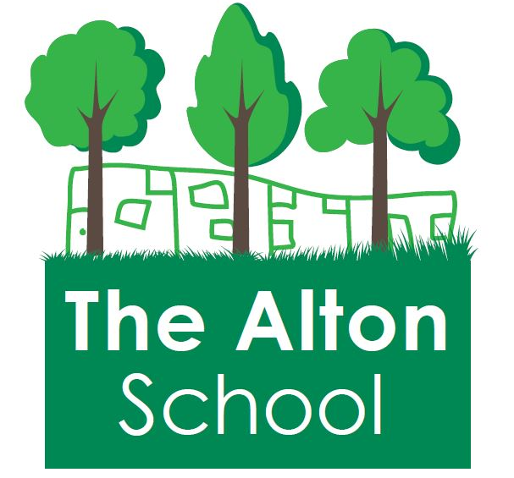
The Alton School Newsletter

Dear Parents, Carers, Friends and Colleagues,
Rights Respecting School
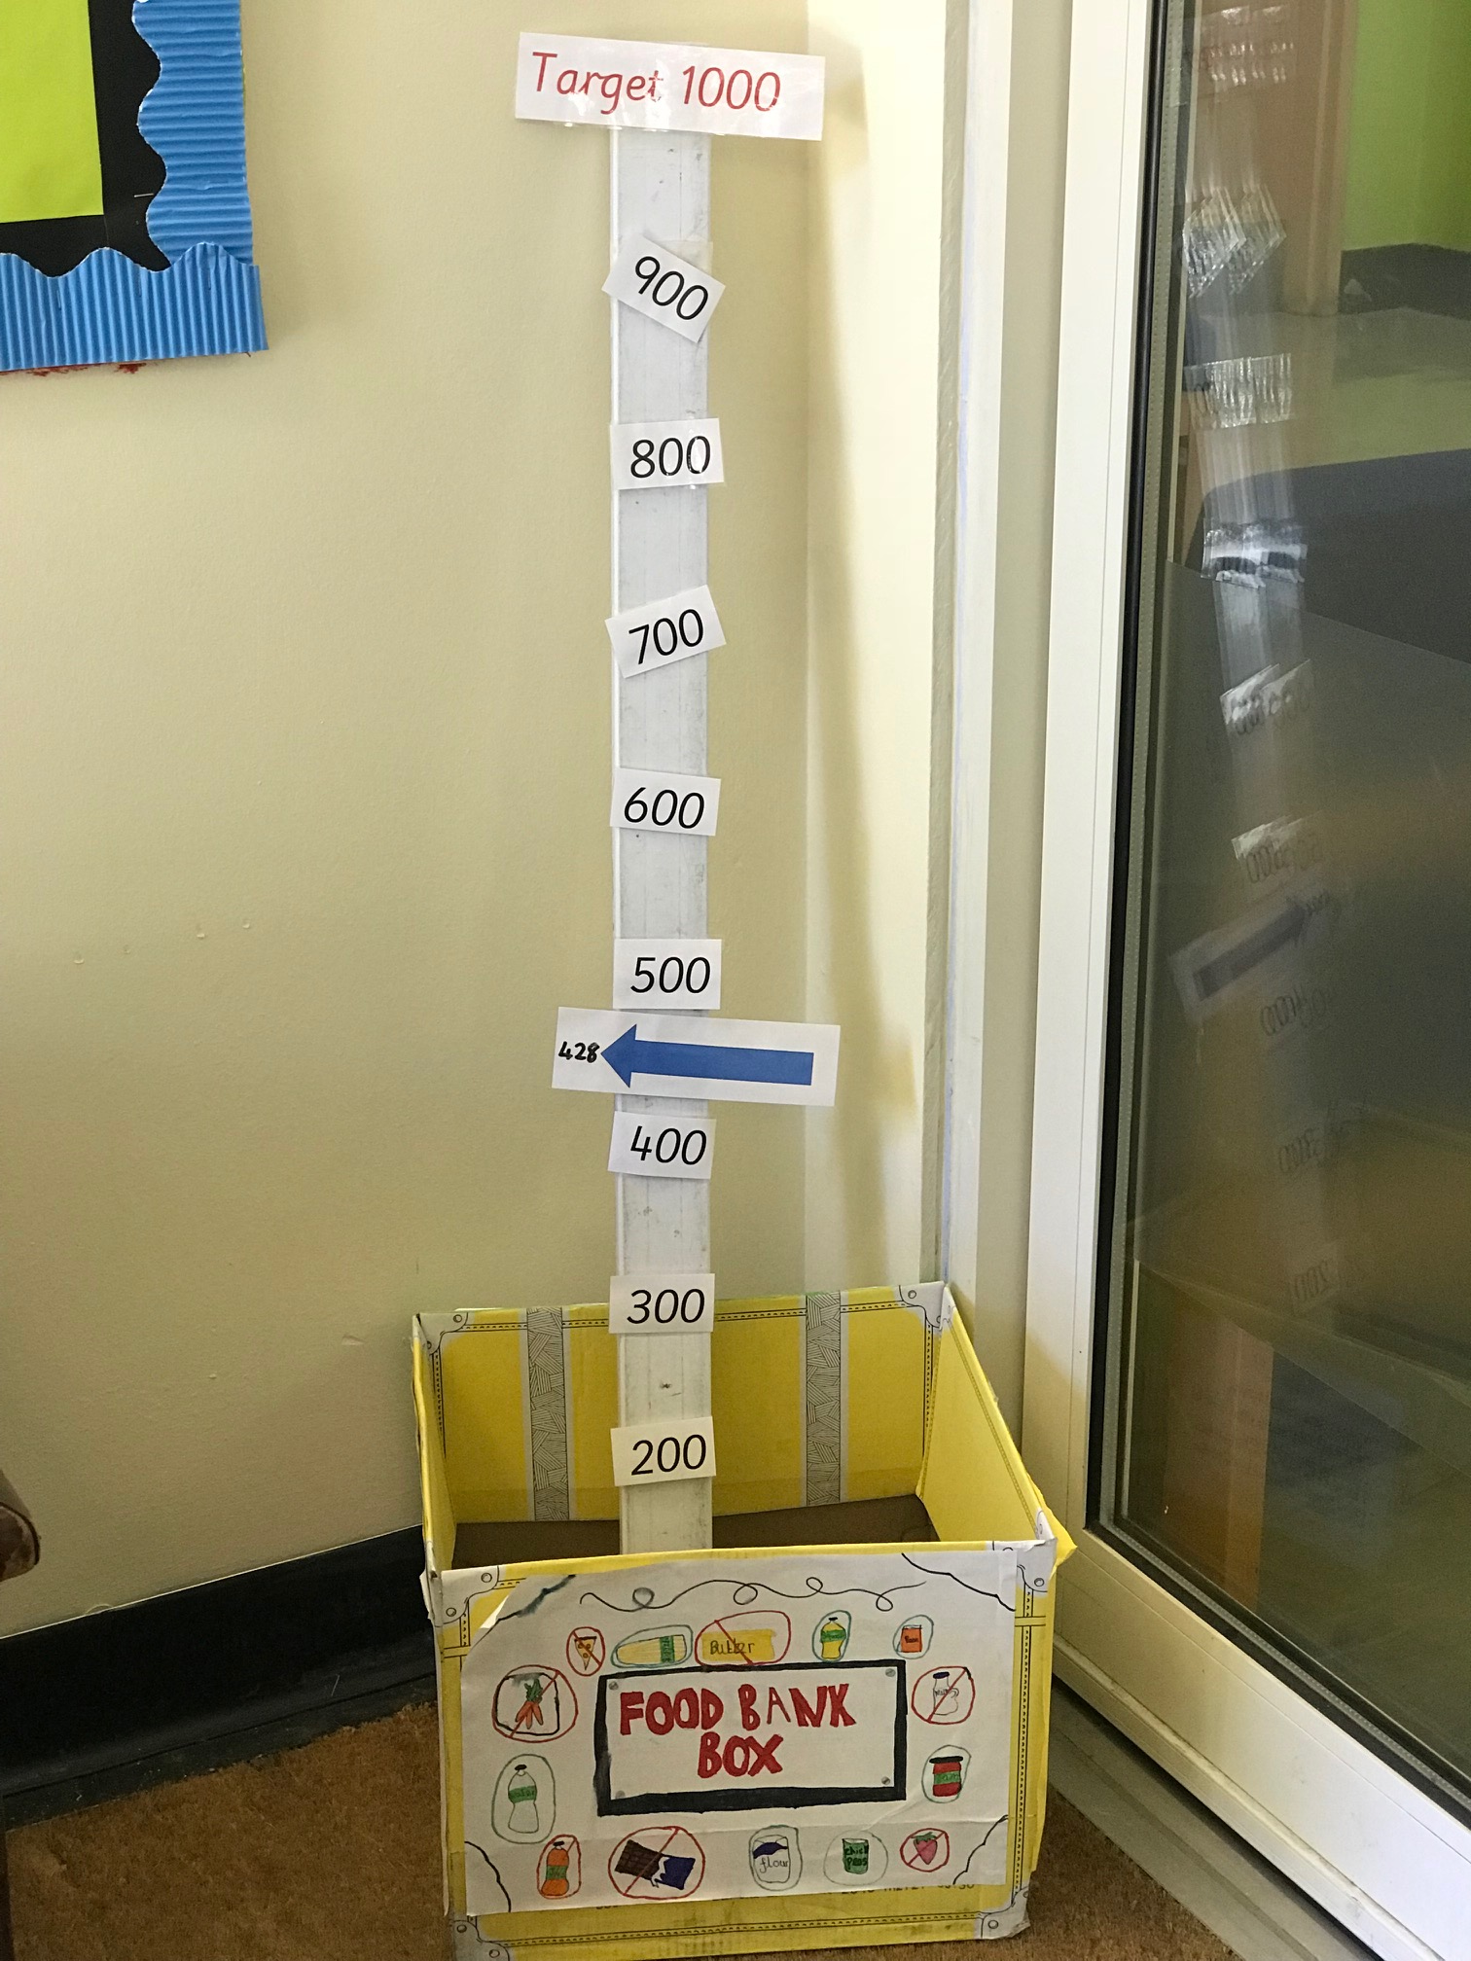
This week we focused on the Article 24: You have the right to nutritious food. Our Excellent Learner quality was: Excellent Learners ask for help. As we have been learning about the right to nutritious food please use this as a chance to make a donation to our food bank collection if you are able to do so:

This Week at The Alton
Throughout the week, Year 6 have been working hard in their SATs tests. We are all incredibly proud of the hard work and dedication they have demonstrated, and want to say ‘Well done!’ for doing such a good job. On Friday Year 5 are visiting the science museum and Year 6 are visiting Palewell Park. We are also enjoying a ‘Royal Wedding’ lunch to celebrate the wedding of Prince Harry and Ms. Meghan Markle.

Next week at The Alton:

On Wednesday Nursery are visiting Deen City Farm and then Reception are visiting the farm on Thursday. The EYFS assembly is on Friday at 3pm.
18th May
2018

14th May Achievement Assembly:
During our Achievement Assemblies, the following students were awarded their certificates:

Big Writers: Javeria(YN); Adnaan(YR); Romaysa(Y1); Cody(Y2); Faatimah(Y3); Mucaed(Y4); Autumn(Y5) Helal(Y6) & Ryan(RB);

Excellent Learners: Jeremiah(YN); Samira(YR); Laiba(Y1); Abyan(Y2); Wafaa(Y3); Ayman(Y4); Dominic(Y5) Zaky(Y6) & Samiha(RB)

Reader of the Week: Salik YN
Rights Respecting Champion: Rahma Y6
Attendance: Year 4 and RB1 100%

Latest Alton Estate proposals:
Wandsworth Council is inviting people to a public exhibition of the Alton Estate regeneration project. There are revised plans to look at and people on-hand to answer questions or comments that you may have. Find out how the regeneration might affect you. It is taking place in Roehampton Parish Hall (formerly known as the Cornerstone) on Wednesday 6th June 3pm-8pm and Saturday 9th June 10am-5pm. A summary of the exhibition will be on display in the library. You can find out more at: www.AltonEstateRegen.co.uk

With best wishes,
Ruth Hudson
Headteacher

Dates for your diary
18th May Year 5 trip to the Science Museum
18th May Year 1 Class assembly 3pm
23rd May Nursery visit to Deen City Farm
24th May Reception visit to Deen City Farm
25th May EYFS assembly 3pm
25th May 3.30pm School closes for half term
28th May to 4th June School is closed to pupils
4th June School closed to pupils but open for staff training and buying uniform. (INSET)
5th -15th June Open lessons
5th June 8am Breakfast club. 8.45am class doors open.
11th June Phonics screening week for Year 1
11th June MUNGA for Year 5 group
12th June Recycling workshops in school
12th June Spelling Bee Y5 and Y6 group
18th June Book Fair arrives
19th June Sports day
25th June MUNGA for Year 5 group
26th June Road safety workshop for Y6
30th June Summer Fair
6th July MUNGA for Year 5 group
11th July Y6 performance to parents
12th July Y6 Prom
18th July Y6 Graduation assembly 2pm
20th July School closes for the summer holidays 12.15pm

