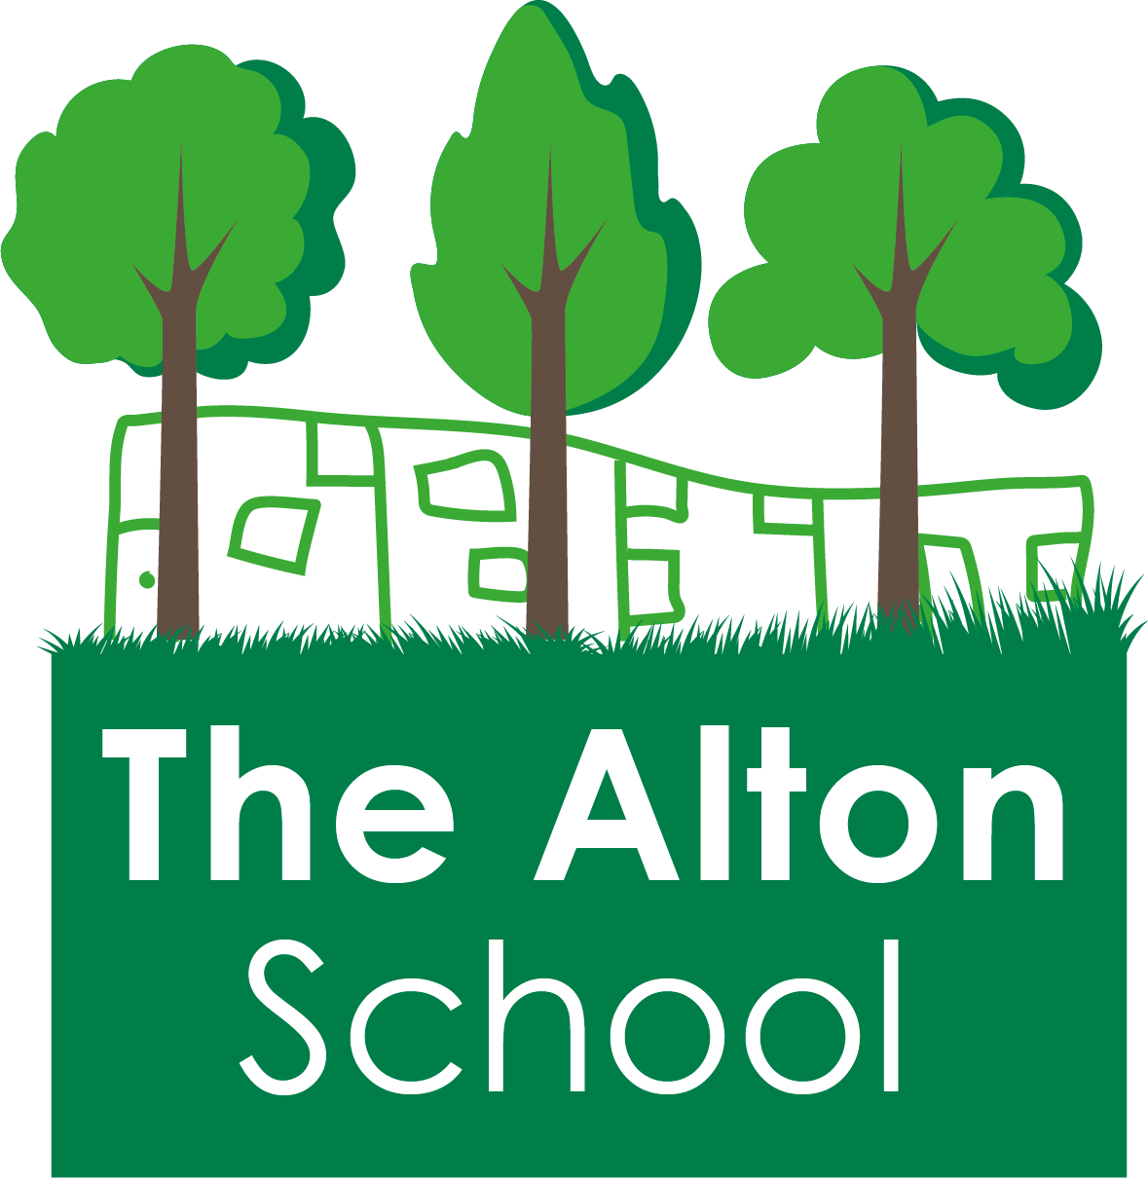
The Alton School Newsletter

Dear Parents, Carers, Friends and Colleagues,
Rights Respecting School
Next week we are focusing on Article 24: Everyone has the right to nutritious food. All children have the right to eat a balanced diet. The students will learn that with this right comes the responsibility to make sensible food choices to keep themselves fit and healthy.
The 16th October is World Food Day, Please can you bring in a donation for the food bank to support those who are less fortunate.
Our Excellent Learner quality is: Are not afraid to make mistakes.
Please support us by using the language of Excellent Learners as well as rights and responsibilities with your children, asking them what they have been learning about.
Secondary School for Year 6
A reminder that applications for secondary schools need to be completed by the 31st October 2018. Please let the office know when you send off your form and tell us which school you have chosen.
School uniform
Thank you to all of you who have ensured that your children come to school in full uniform. Please make sure that your children have suitable warm clothing to go outside and play. The new sweatshirts have now arrived from the supplier and we have all sizes in stock.

12th October 2018
Ibstock readers
Pupils from Ibstock School have volunteered to support our children with their reading and helping them to understand text.
They are also volunteering in the school library after school on Fridays from 3:15 – 3:45 pm. The library will be open so that children can take out a book to readapt home or share a book with a volunteer after school.
This week at The Alton
This week has been a very exciting week at The Alton
During the week 4 students from Roehampton University visited the children in year 1 and year 5 as part of their teacher training course.
On Tuesday, children in year 5 attended the junior citizenship day, where they enjoyed participating in challenges and learning how to be a global citizen. They all went to Palewell park in the afternoon and enjoyed the lovely outdoor weather we have been having.
On Wednesday Year 2 went to the London Transport Museum and had an amazing time looking at the old buses and trams.
Year 6 visited Heathmere School to see the author Anthony Horrowitz, they had a super time listening to him speak about his books and experiences. He writes the Alex Rider series of books which are very popular, I am sure the children were inspired to read some of his work after the session.
On Thursday Year 1 students visited Wisley RHS Gardens to learn about the changing seasons. They had a fantastic time exploring the gardens and enjoyed a teacher led session. They all came back wearing the beautiful seasonal crowns that they had made.
We are working for our Gold Rights Respecting Schools award and I hope that you have noticed the lovely new posters about our rights that have been put up on the school entrance path.
Today Year 3 had their class assembly and I am sure that you enjoyed finding out about all their learning this half term.
Parent and Carer suggestions
We have a new area in the front of the school office for you to leave a suggestion or question. You can also call us on 020 8876 8482, email admin@thealton.wandsworth.sch.uk or download a suggestion form from our website. These will also be addressed in our newsletters if it is helpful to many parents.

With best wishes,

Ruth Hudson
Headteacher

Dates for your diary
12th Oct 2.50pm Y3 Class Assembly
16th Oct World Food Day
19th 0ct 3.15pm School closes for half term.
22nd to 26th October school is closed to pupils – half term holiday
29th Oct 7.45am Breakfast club. 8.30am classes open.
2nd Nov 2.50pm Y2 Assembly
9th Nov 2.50pm Y1 Assembly
16th Nov Children In Need
23rd Nov 2.50pm EYrs Assembly
18th Dec 2pm School Christmas Play
21th Dec 3.15pm School closes for Christmas
24th December 2018 to 7th January 2019 School is closed to pupils
7th Jan School closed to pupils but open for staff training and buying uniform. (INSET)
8th Jan 7.45am Breakfast club. 8.30am classes open.
18th Jan 2.50pm Y6 Class Assembly
25th Jan 2.50pm Y5 Class Assembly
1st Feb 2.50pm Y4 Class Assembly
8th Feb 2.50pm Y3 Class Assembly
15th Feb 3.15pm School closes for half term
18th to 22nd February School closed to pupils – half term holiday
25th Feb 7.45am Breakfast club. 8.30am classes open.
8th Mar 2.50pm Y2 Class Assembly
15th Mar 2.50pm Y1 Class Assembly
22nd Mar 2.50pm EYrs Class Assembly
5th April 3.15pm School closes for Easter
8th April to 22nd April School is closed to pupils – Easter Holidays
23rd Apr 7.45am Breakfast club. 8.30am classes open.
6th May School closed for Bank Holiday
27th May 3.15pm School closes for half term
27th May to 31st May School is closed to pupils – half term holiday
3rd June School closed to pupils but open for staff training and buying uniform. (INSET)
4th June 7.45am Breakfast club. 8.30am classes open.

